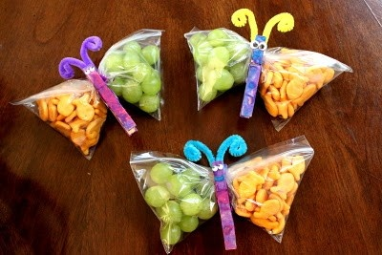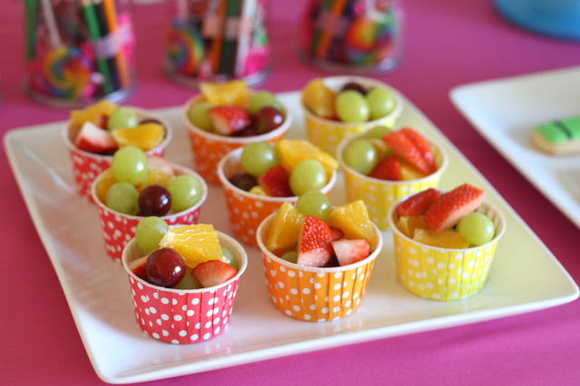
Birthday Treats!
Birthday Treats are healthy treats! Per our school rule, children will only be allowed to bring in a healthy or a non-edible treat to share with the class for their birthday, if they choose to bring something in to share. This may include: fruit cups/kababs, bouncy balls, pencils, temporary tattoos, glow sticks, etc. Children with summer birthdays can bring a treat in on their half birthday if they wish. We have 22 children in our class at this time.

If the treat is anything that may get crummy or messy, please supply plates or napkins. This will help tremendously!!

We will celebrate the birthdays in the morning. Please have the treat here by 9:00. If your child can’t bring it, you can drop it off in the office. Time will NOT be given for parents to come down to the room to set up the snack.

Finally, parents wanting to come in during the school day to help their child celebrate their birthday are asked to do so at their child’s lunch/recess time. This way, the learning of all students will not be disrupted.

