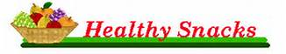
Our morning routine will include time for the students to eat a light, healthy snack. Snack time will normally be schedule any time before lunch. Because we want the student’s brain to have energy, please pack a healthy snack for your child (fruit, cut up veggies, string cheese, frozen g0-gurt, popcorn, etc.). Drinks can become very messy in the classroom, so please refrain from sending in drinks for snack time. They will be able to use the drinking fountain at any time.
Thank you for helping to get your child energized for some high powered learning all morning long! If you have any questions or comments, please feel free to contact me.

